Oz Robot Puppeteering System
protocol 1.0
by Desmond Germans
Germans Media Technology & Services

1-5-2014: first version

Overview
This document describes the exact protocol between client (controlling computer) and server (the robot) for the Oz Robot Puppeteering System. This system is designed especially for social robotics and supports speech synthesis, speech recognition, face detection and a small variety of concurrent nonverbal communication styles for the robot.
Figure 1. shows a system overview.

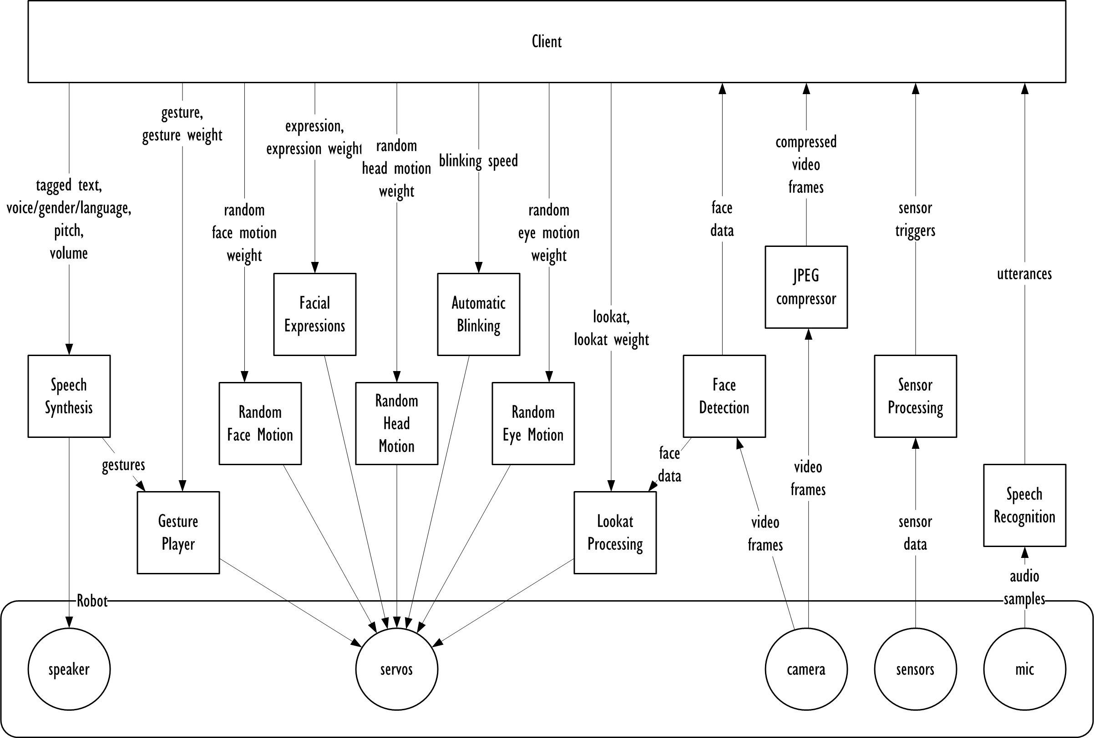
Figure 1. Oz Robot Puppeteering System overview

At the top is the client, in the middle the various software components that make up the system, and at the bottom the robot hardware.
Communications between client and server is done over a TCP connection. The protocol is very simple and direct, and relies on an uninterupted reliable full-duplex stream between client and server. There is no error recovery and no security.
All data is transmitted in big-endian format. This means that of a longer integer (uint16, uint32, uint64, etc.) the individual bytes are transmitted in hi-to-lo order, like this:
Type | Transmitted as | Example data | Transmitted bytes
char/int8/uint8 | no change | 0x01 | 0x01
int16/uint16 | first the high byte, then the low byte | 0x0123 | 0x01 0x23
int32/uint32 | first the highest byte, ..., finally the lowest byte | 0x01234567 | 0x01 0x23 0x45 0x67
float | treat binary as uint32 | 0.390625 (0x43A4B200) | 0x43 0xA4 0xB2 0x00
string | first uint16 to indicate number of bytes, then the bytes encoded as UTF-8 | "Hello" | 0x00 0x05 0x47 0x65 0x6C 0x6C 0x6F

Initialization
The client connects to the server (typically port 7331) and does a version request. The server responds with the version number and the server's short and long names as follows:
A connection is established between client and server.
The client sends MSG_VERSION_REQUEST, followed by the version number:
Offset | Type | Description
0 | uint32 | MSG_VERSION_REQUEST (0x00000001)
4 | uint32 | requested version number (currently 0x01000000)

The server responds with the supported version number and two strings:
Offset | Type | Description
0 | uint32 | version number (currently 0x01000000)
4 | uint16 | number of bytes in short name string (n)
6 | char[n] | short name string
6 + n | uint16 | number of bytes in long name string (m)
8 + n | char[m] | long name string

If the version number does not match, the client may choose to abort, or fallback to an earlier supported version.
When the version numbers match, the server starts transmitting video frames, detected faces and understood utterances to the client. The client should handle all of the messages accordingly and asynchronously.
At any time, the client can reset the server by sending MSG_RESET as follows:
Offset | Type | Description
0 | uint32 | MSG_RESET (0x00000002)

Speech Synthesis
The client can send text string to the server for parsing and speaking out loud. The text string can contain gesture tags to trigger specific gestures inside the speech. This way, the server can raise eyebrows at specific words, nod where it is appropriate in the sentence, etc.
Sending text to the robot goes as follows:
Offset | Type | Description
0 | uint32 | MSG_SPEAK (0x00000003)
4 | uint16 | number of bytes in text string (n)
6 | char[n] | text string

The server immediately starts speaking. When gestures are triggered from the text, the server sends back MSG_SPEAK_GESTURE messages, and when the server is finished, it sends a MSG_SPEAK_DONE message to indicate readiness.
The MSG_SPEAK_GESTURE message looks like this:
Offset | Type | Description
0 | uint32 | MSG_SPEAK_GESTURE
4 | uint32 | gesture ID
For the possible gesture IDs, see Gestures section.
The MSG_SPEAK_DONE message looks like this:
Offset | Type | Description
0 | uint32 | MSG_SPEAK_DONE (0x00000014)

Next to this, the client can request a different language, gender, voice, pitch and volume. To change language/gender/voice, the client sends a MSG_VOICE_GENDER_LANGUAGE message:
Offset | Type | Description
0 | uint32 | MSG_VOICE_GENDER_LANGUAGE (0x00000004)
4 | uint32 | voice/gender/language combination
At the moment, the only valid combination is VCL_DEFAULT (0x00000000)
To change the pitch, the client sends a MSG_VOICE_PITCH message:
Offset | Type | Description
0 | uint32 | MSG_VOICE_PITCH (0x00000005)
4 | float | new pitch (0.5..2.0), default is 1.0
Finally, to change the volume, the client sends a MSG_VOICE_VOLUME message:
Offset | Type | Description
0 | uint32 | MSG_VOICE_VOLUME (0x00000006)
4 | float | new volume (0.0..1.0), default is 1.0

Speech Recognition
Speech recognition is fully automatic. The server informs the client whenever it heard something it understood. It does so via the MSG_UTTERANCE to the client. The message contains one or more strings with associated confidence, like so:
Offset | Type | Description
0 | uint32 | MSG_UTTERANCE (0x00000017)
4 | uint32 | number of options (n)
8 | option[n] | The options (see below)
Each option is transmitted as follows:
Offset | Type | Description
0 | float | confidence factor (0.0..1.0)
4 | uint16 | number of bytes in text string (n)
6 | char[n] | text string
The first option always has the highest confidence.

Eye Video
After initialization, the server will start to transmit compressed video frames from the camera. The frames are compressed as regular JPEG images, and transmitted as follows:
Offset | Type | Description
0 | uint32 | MSG_VIDEO_FRAME (0x00000019)
4 | uint32 | Number of bytes in compressed image data (n)
8 | uint8[n] | Compressed image data

The client should always process the incoming MSG_VIDEO_FRAME messages, but could ofcourse immediately discard the data if no video is used.

Face Detection
The server will automatically detect if the camera image contains a face, and build up a list of faces it finds. When it succesfully detects one or more faces, it sends the MSG_FACES message back to the client as follows:
Offset | Type | Description
0 | uint32 | MSG_FACES (0x00000018)
4 | uint32 | Number of faces found (n)
8 | face[n] | The faces (see below)

Each face is transmitted as follows:
Offset | Type | Description
0 | float | confidence factor (0.0..1.0)
4 | float | X-coordinate of face (-1.0..1.0, -1.0 is far left, 1.0 is far right)
8 | float | Y-coordinate of face (-1.0..1.0, -1.0 is far up, 1.0 is far down)
12 | float | width of face (0.0..1.0, 1.0 is full video width)
16 | float | height of face (0.0..1.0, 1.0 is full video height)
20 | uint16 | number of bytes in name string (n)
22 | char[n] | name string

Servo Mixer
The server moves using several servo controllers controlling all the body, face and hand servos. With Oz, servo control is a mix of a variety of subsystems that all operate simultaneously (Figure 2).
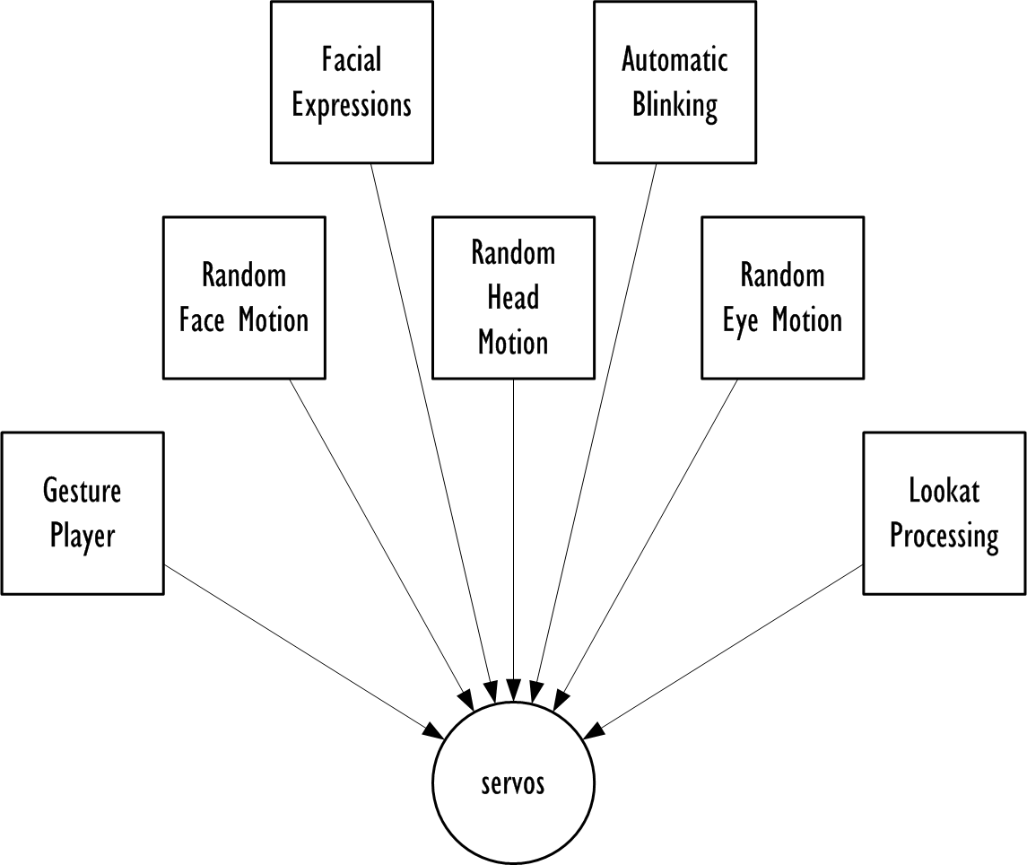
Figure 2. The various subsystems that mix together into the final servo motions.
The client can specify a weighing factor for each of the 7 subsystems. All weights are defined between 0.0 and 1.0, where 0.0 means no contribution and 1.0 means full contribution. The weights can be specified by the client:
Offset | Type | Description
0 | uint32 | weight message (see below)
4 | float | weighing factor (0.0..1.0)

The weight messages for the various weights are:
Message | Description
MSG_GESTURE_WEIGHT (0x00000008) | gesture weight (default is 1.0)
MSG_EXPRESSION_WEIGHT (0x0000000A) | facial expression weight (default is 1.0)
MSG_RANDOM_HEAD_WEIGHT (0x0000000C) | random head motion weight (default is 0.0)
MSG_RANDOM_EYES_WEIGHT (0x0000000D) | random eyes motion weight (default is 0.0)
MSG_RANDOM_FACE_WEIGHT (0x0000000E) | random face motion weight (default is 0.0)
MSG_LOOKAT_WEIGHT (0x00000013) | lookat weight (default is 1.0)

Lookat Functionality
The found face data can be used to have the robot automatically deal with looking at the person it is talking to. The client can specify one of several lookat modes as follows:
Offset | Type | Description
0 | uint32 | MSG_LOOKAT (0x00000012)
4 | uint32 | lookat mode (see below)

The available modes are:
Mode | Description
LOOKAT_FORWARD (0x00000000) | The robot looks forward (default)
LOOKAT_DOWN (0x00000001) | The robot looks down
LOOKAT_UP (0x00000002) | The robot looks up
LOOKAT_LARGEST (0x00000003) | The robot follows the largest (closest) face
LOOKAT_SMALLEST (0x00000004) | The robot follows the smallest (furthest) face
LOOKAT_AWAY (0x00000005) | The robot tries to avoid any face

Gestures
Gestures are small servo animations to convey a non-verbal communication signal. The client can start a gesture, or a gesture can be started from the speech synthesizer. To start a gesture, the client sends:
Offset | Type | Description
0 | uint32 | MSG_GESTURE (0x00000007)
4 | uint32 | Gesture ID (see below)

The gestures Ids and corresponding text tags are as follows:
ID | Tag | Description
GESTURE_BROW_RAISE_LONG (0x00000000) | [braisel] | Long raise of the eyebrows
GESTURE_BROW_RAISE_SHORT (0x00000001) | [braises] | Short raise of the eyebrows
GESTURE_FROWN_LONG (0x00000002) | [frownl] | Long frown of the eyebrows
GESTURE_FROWN_SHORT (0x00000003) | [frowns] | Short frown of the eyebrows
GESTURE_YES_LONG (0x00000004) | [yesl] | Long yes-motion
GESTURE_YES_SHORT (0x00000005) | [yess] | Short yes-motion
GESTURE_YES_LONG_3X (0x00000006) | [yesl3] | Triple long yes-motion
GESTURE_YES_SHORT_3X (0x00000007) | [yess3] | Triple short yes-motion
GESTURE_NO_LONG (0x00000008) | [nol] | Long no-motion
GESTURE_NO_SHORT (0x00000009) | [nos] | Short no-motion
GESTURE_NO_LONG_3X (0x0000000A) | [nol3] | Triple long no-motion
GESTURE_NO_SHORT_3X (0x0000000B) | [nos3] | Triple short no-motion
GESTURE_INDIAN_WOBBLE (0x0000000C) | [wob] | Indian head wobble

When a gesture animation is done, the server sends MSG_GESTURE_DONE to the client to indicate readiness. It does so for gestures started with MSG_GESTURE as well as gestures started from speaking. The server is capable of playing multiple gestures simultaneously. For instance, speaking "[braisel][nos]Nope." will have the server say "Nope." with raised eyebrows and a small head shake.

Facial Expressions
Next to lookat processing and gestures, the client can request a more permanent facial expression:
Offset | Type | Description
0 | uint32 | MSG_EXPRESSION (0x00000009)
4 | uint32 | facial expression ID (see below)

The facial expression IDs are:
Mode | Description
EXPRESSION_NEUTRAL (0x00000000) | neutral expression
EXPRESSION_HAPPY (0x00000001) | smile and raised eyebrows
EXPRESSION_SAD (0x00000002) | sad and frowning
EXPRESSION_EVIL (0x00000003) | smile and frowning
EXPRESSION_AFRAID (0x00000004) | Sad and raised eyebrows

Automatic Motions
As described in the servo mixing section, there are several automatic motions that the client can mix together. The server can automatically blink with the eyelids, randomly move the eye gaze, randomly move smiling and frowning and randomly move the entire head.
To indicate the automatic blinking speed, the client sends:
Offset | Type | Description
0 | uint32 | MSG_AUTO_BLINK_SPEED (0x0000000B)
4 | float | New automatic blinking speed in times per second (0.0..10.0), default is 2.0

Client APIs
There are various client APIs available for Oz, all presenting a similar set of methods to the programming environment.

C Client
This is the most basic client, with a very straightforward interface. The API defines the following:
typedef void* OZ;
OZ oz_connect(char* hostname,int port); // connect to server, returns null if failed
void oz_disconnect(OZ oz); // disconnect from server
void oz_reset(OZ oz); // reset server
char* oz_name(OZ oz); // return server short name
char* oz_long_name(OZ oz); // return server long name
void oz_speak(OZ oz,char* text); // start speaking
int oz_is_speaking(OZ oz); //
void oz_set_voice_gender_language(OZ oz,int vgl);
int oz_get_voice_gender_language(OZ oz);
void oz_set_volume(OZ oz,float v);
float oz_get_volume(OZ oz);
void oz_set_pitch(OZ oz,float p);
float oz_get_pitch(OZ oz);
void oz_gesture(OZ oz,int id);
int oz_is_gesturing(OZ oz);
void oz_set_gesture_weight(OZ oz,float w);
float oz_get_gesture_weight(OZ oz);
void oz_set_expression(OZ oz,int id);
int oz_get_expression(OZ oz);
void oz_set_expression_weight(OZ oz,float w);
float oz_get_expression_weight(OZ oz);
void oz_set_auto_blink_speed(OZ oz,float s);
float oz_get_auto_blink_speed(OZ oz);
void oz_set_random_head_weight(OZ oz,float w);
float oz_get_random_head_weight(OZ oz);
void oz_set_random_eyes_weight(OZ oz,float w);
float oz_get_random_eyes_weight(OZ oz);
void oz_set_random_face_weight(OZ oz,float w);
float oz_get_random_face_weight(OZ oz);
void oz_set_servo(OZ oz,int id,float pos);
float oz_get_servo(OZ oz,int id);
void oz_set_all_servos(OZ oz,float* pos);
void oz_get_all_servos(OZ oz,float* pos);
void oz_set_direct_weight(OZ oz,float w);
float oz_get_direct_weight(OZ oz);
void oz_set_lookat(OZ oz,int id);
int oz_get_lookat(OZ oz);
void oz_set_lookat_weight(OZ oz,float w);
float oz_get_lookat_weight(OZ oz);

C++ Qt5 Client
This is a client that can integrate seamlessly with Qt applications in C++. The API defines the following:
struct Utterance
{
int options;
struct
{
float confidence;
char text[1024];
} option[16];
Utterance();
Utterance(const Utterance& a);
Utterance& operator=(const Utterance& a);
};

struct Faces
{
int faces;
struct
{
float confidence;
float x,y;
float xsize,ysize;
char identity[1024];
} face[16];
Faces();
Faces(const Faces& a);
Faces& operator=(const Faces& a);
};

class QClient1 : public QObject
{
Q_OBJECT

public:
QClient1();
~QClient1();

// network connection
void connectToHost(const QString& hostName,quint16 port,QIODevice::OpenMode openMode = QIODevice::ReadWrite,QAbstractSocket::NetworkLayerProtocol protocol = QabstractSocket::AnyIPProtocol); // connect to server
void connectToHost(const QHostAddress& address,quint16 port,QIODevice::OpenMode openMode = QIODevice::ReadWrite); // connect to server
bool waitForConnected(int msecs = 30000); // wait for connection to establish
void disconnectFromHost(); // disconnect from server

// administrative
void reset(); // reset server
QString name(); // return short name of server
QString longName(); // return long name of server

// speaking
void speak(QString& text); // speak text
void waitForSpeak(); // wait for speech to finish
bool speaking(); // return true if server is speaking
void setVoiceGenderLanguage(int vgl); // set new voice/gender/language
int voiceGenderLanguage(); // get current voice/gender/language
void setVoiceVolume(float volume); // set new volume
float voiceVolume(); // return current volume
void setVoicePitch(float pitch); // set new pitch
float voicePitch(); // return current pitch

// gestures
void gesture(int id); // start gesture
void waitForGesture(); // wait for gesture to finish
bool gesturing(); // return true if gesture is playing
void setGestureWeight(float weight); // set new gesture weighing factor
float gestureWeight(); // return current gesture weighing factor

// facial expression
void setExpression(int expr); // set new facial expression
int expression(); // return current facial expression
void setExpressionWeight(float weight); // set new expression weighing factor
float expressionWeight(); // return current expression weighing factor

// automatic motion
void setAutoBlinkSpeed(float speed); // set new automatic blink speed
float autoBlinkSpeed(); // return current automatic blink speed
void setRandomHeadWeight(float weight); // set new random head motion weighing factor
float randomHeadWeight(); // return current random head motion weighing factor
void setRandomEyesWeight(float weight); // set new random eyes motion weighing factor
float randomEyesWeight(); // return current random eyes motion weighing factor
void setRandomFaceWeight(float weight); // set new random face motion weighing factor
float randomFaceWeight(); // return current random face motion weighing factor

// direct servo control
void setServo(int id,float pos); // set new direct servo position
float servo(int id); // return currently set direct servo position
void setAllServos(float* pos); // set all direct servo positions
void allServos(float* pos); // return all direct servo positions
void setDirectWeight(float weight); // set new direct servo position weighing factor
float directWeight(); // return current direct servo position weighing factor

// looking at faces
void setLookAt(int target); // set new lookat target
int lookAt(); // return current lookat target
void setLookAtWeight(float weight); // set new lookat weighing factor
float lookAtWeight(); // return current lookat weighing factor

// signals
signals:
void connected(); // triggered when connection is established
void disconnected(); // triggered when connection is lost
void speakStart(); // triggered when speaking starts
void speakDone(); // triggered when speaking is done
void gestureStart(int id); // triggered when gesture starts
void gestureDone(); // triggered when gesture is done
void speakGesture(int id); // triggered when speech starts a gesture
void utterance(Utterance& a); // triggered when server hears new utterances
void faces(Faces& a); // triggered when server sees new faces
void jpegVideoFrame(unsigned char* jpeg,int length); // triggered when new eye camera frame arrives
};

Java Client
This is a straightforward Java client. The API defines the following:

C# Client
This is a straightforward Mono/C# client. The API defines the following:

Python Client
This is a straightforward Python client. The API defines the following:

Node.js Client
This is a Javascript client for use with node.js servers. The API defines the following:

Java Android Client
This is a client that can integrate seamlessly with Android applications. The API defines the following:

The Importantest Main Header File With Constants And Definitions And Shit
This is the main C/C++ header file used in this version of the protocol. All client APIs, as well as server implementations are derived from it.
// OZ - Robot Puppeteering System Client Protocol, up to version 1.0
// (C) Copyrights by Desmond Germans
// 2014 Germans Media Technology & Services
#ifndef _OZ_PROTOCOL_H_
#define _OZ_PROTOCOL_H_
namespace oz
{
// the port
enum
{
OZ_PORT = 7331
};
// servo ids
enum
{
// body
SERVO_WAIST = 0,
// left arm
SERVO_SHOULDER_PITCH_LEFT,
SERVO_SHOULDER_ROLL_LEFT,
SERVO_ELBOW_YAW_LEFT,
SERVO_ELBOW_PITCH_LEFT,
// right arm
SERVO_SHOULDER_PITCH_RIGHT,
SERVO_SHOULDER_ROLL_RIGHT,
SERVO_ELBOW_YAW_RIGHT,
SERVO_ELBOW_PITCH_RIGHT,
// left leg
SERVO_HIP_ROLL_LEFT,
SERVO_HIP_YAW_LEFT,
SERVO_HIP_PITCH_LEFT,
SERVO_KNEE_PITCH_LEFT,
SERVO_ANKLE_PITCH_LEFT,
SERVO_ANKLE_ROLL_LEFT,
// right leg
SERVO_HIP_ROLL_RIGHT,
SERVO_HIP_YAW_RIGHT,
SERVO_HIP_PITCH_RIGHT,
SERVO_KNEE_PITCH_RIGHT,
SERVO_ANKLE_PITCH_RIGHT,
SERVO_ANKLE_ROLL_RIGHT,
// head
SERVO_NECK_YAW,
SERVO_NECK_ROLL,
SERVO_NECK_PITCH,
SERVO_BROWS,
SERVO_EYELIDS,
SERVO_EYES_PITCH,
SERVO_JAW,
SERVO_EYE_YAW_RIGHT,
SERVO_SMILE_LEFT,
SERVO_EYE_YAW_LEFT,
SERVO_SMILE_RIGHT,
// left hand
SERVO_WRIST_LEFT,
SERVO_GRASP_LEFT,
// right hand
SERVO_WRIST_RIGHT,
SERVO_GRASP_RIGHT,
MAX_SERVOS // last servo indicator, do not use
};
// voice/gender/language specifications
enum
{
VGL_DEFAULT = 0
};
// gestures
enum
{
GESTURE_BROW_RAISE_LONG = 0,
GESTURE_BROW_RAISE_SHORT,
GESTURE_FROWN_LONG,
GESTURE_FROWN_SHORT,
GESTURE_YES_LONG,
GESTURE_YES_SHORT,
GESTURE_YES_LONG_3X,
GESTURE_YES_SHORT_3X,
GESTURE_NO_LONG,
GESTURE_NO_SHORT,
GESTURE_NO_LONG_3X,
GESTURE_NO_SHORT_3X,
GESTURE_INDIAN_WOBBLE,
MAX_GESTURES
};
// facial expressions
enum
{
EXPRESSION_NEUTRAL = 0,
EXPRESSION_HAPPY,
EXPRESSION_SAD,
EXPRESSION_EVIL,
EXPRESSION_AFRAID
};
// lookat targets
enum
{
LOOKAT_FORWARD = 0,
LOOKAT_DOWN,
LOOKAT_UP,
LOOKAT_LARGEST,
LOOKAT_SMALLEST,
LOOKAT_AWAY
};

// messages
enum
{
MSG_NOTHING = 0,
// admin
MSG_REQUEST_VERSION, // request particular version of the API, dword = version (0x01000000 = 1.0), robot returns version as answer, followed by name and long name
MSG_RESET, // reset robot
// speaking
MSG_SPEAK, // speak, text = utterance
MSG_VOICE_GENDER_LANGUAGE, // set voice/gender/language, dword = VCL_* (default = VCL_DEFAULT)
MSG_VOICE_VOLUME, // set voice volume, float = volume (0..1, default = 1)
MSG_VOICE_PITCH, // set voice pitch, float = pitch (0..2, default = 1)
// gesturing
MSG_GESTURE, // manually trigger gesture, dword = GESTURE_*
MSG_GESTURE_WEIGHT, // set gesture weight, float = weight (0..1, default = 1)
// facial expression
MSG_EXPRESSION, // set facial expression, dword = EXPRESSION_* (default = EXPRESSION_NEUTRAL)
MSG_EXPRESSION_WEIGHT, // set facial expression weight, float = weight (0..1, default = 1)
// automatic motion
MSG_AUTO_BLINK_SPEED, // set automatic blink speed, float = speed in Hz (0..10, default = 0, no blinking)
MSG_RANDOM_HEAD_WEIGHT, // set random head motion weight, float = weight (0..1, default = 0)
MSG_RANDOM_EYES_WEIGHT, // set random eyes motion weight, float = weight (0..1, default = 0)
MSG_RANDOM_FACE_WEIGHT, // set random face motion weight, float = weight (0..1, default = 0)
// direct servo control
MSG_SERVO, // set servo position, dword = id, float = position (0..1, default = 0)
MSG_ALL_SERVOS, // set all servo positions, { float = position (0..1, default = 0) }
MSG_DIRECT_WEIGHT, // set direct servo control weight, float = weight (0..1, default = 0)
// looking at faces
MSG_LOOKAT, // set lookat target, dword = LOOKAT_* (default = LOOKAT_FORWARD)
MSG_LOOKAT_WEIGHT, // set lookat weight, float = weight (0..1, default = 0)
// events from robot
MSG_SPEAK_DONE, // speak is done
MSG_GESTURE_DONE, // gesture is done
MSG_SPEAK_GESTURE, // speak-triggered gesture, dword = GESTURE_*
MSG_UTTERANCE, // utterance found, dword = count, { float = confidence, text = utterance }
MSG_FACES, // new face recognition state, dword = count, { float = confidence, float = x, float = y, float = xsize, float = ysize, text = identity }
MSG_VIDEO_FRAME, // single video frame from the robot, dword = length, data blob
};
}
#endif

